**Knowledge Representation in AI**

knowledge representation (KR) in AI refers to **encoding information about the world into formats that AI systems can utilize to solve complex tasks.** This process enables machines to reason, learn, and make decisions by structuring data in a way that mirrors human understanding.

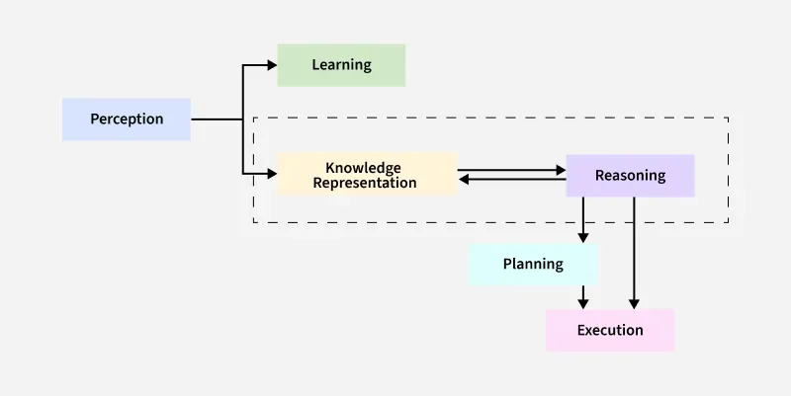Knowledge Representation in AI

*Artificial intelligence systems operate on data.* ***However, raw data alone does not lead to intelligence****.* ***AI must transform data into structured knowledge.*** *KR achieves this by defining formats and methods for organizing information. With clear representations, AI systems solve problems, make decisions, and learn from new experiences.*

**The Synergy of Knowledge and Intelligence**

Knowledge and intelligence in AI share a symbiotic relationship:

* **Knowledge as a Foundation**: Knowledge provides facts, rules, and data (e.g., traffic laws for self-driving cars). Without it, intelligence lacks the raw material to act.
* **Intelligence as Application**: Intelligence applies knowledge to solve problems (e.g., a robot using physics principles to navigate terrain).
* **Interdependence**: Static knowledge becomes obsolete without adaptive intelligence. Conversely, intelligence without knowledge cannot reason or learn (e.g., an AI with no medical database cannot diagnose diseases).
* **Synergy**: Effective AI systems merge robust knowledge bases (the *what*) with reasoning algorithms (the *how*). For example, ChatGPT combines vast language data (knowledge) with transformer models (intelligence) to generate coherent text.

**Core Methods of Knowledge Representation**

**1. Logic-Based Systems**

Logic-based methods use formal rules to model knowledge. These systems prioritize precision and are ideal for deterministic environments.

* [**Propositional Logic**](https://www.geeksforgeeks.org/proposition-logic/)  
  Represents knowledge as declarative statements (propositions) linked by logical operators like AND, OR, and NOT. For example, "If it rains (A) AND the ground is wet (B), THEN the road is slippery (C)." While simple, it struggles with complex relationships. Often follow the format "IF condition THEN conclusion." For instance, in a knowledge-based system, you might have:

*IF an object is red AND round, THEN the object might be an apple.*

* [**First-Order Logic (FOL)**](https://www.geeksforgeeks.org/first-order-logic-in-artificial-intelligence/)  
  Extends propositional logic by introducing variables, quantifiers, and predicates. FOL can express statements like, “All humans (∀x) are mortal (Mortal(x)).” It supports nuanced reasoning but demands significant computational resources.

Legal AI tools apply logic-based rules to analyze contracts for compliance.

**2. Structured Representations**

These methods organize knowledge hierarchically or through networks, mimicking how humans categorize information.

* [**Semantic Networks**](https://www.geeksforgeeks.org/semantic-networks-in-artificial-intelligence/)  
  Represent knowledge as nodes (concepts) and edges (relationships). For example, "Dog" links to "Animal" via an "Is-A" connection. They simplify inheritance reasoning but lack formal semantics.
* **Frames**  
  Group related attributes into structured "frames." A "Vehicle" frame may include slots like wheels, engine type, and fuel. Frames excel in default reasoning but struggle with exceptions.
* [**Ontologies**](https://www.geeksforgeeks.org/introduction-to-ontologies/)  
  Define concepts, hierarchies, and relationships within a domain using standards like OWL (Web Ontology Language). Ontologies power semantic search engines and healthcare diagnostics by standardizing terminology.

E-commerce platforms use ontologies to classify products and enhance search accuracy.

**3. Probabilistic Models**

These systems handle uncertainty by assigning probabilities to outcomes.

* [**Bayesian Networks**](https://www.geeksforgeeks.org/basic-understanding-of-bayesian-belief-networks/)  
  Use directed graphs to model causal relationships. Each node represents a variable, and edges denote conditional dependencies. For instance, a Bayesian network can predict the likelihood of equipment failure based on maintenance history and usage.
* [**Markov Decision Processes (MDPs)**](https://www.geeksforgeeks.org/markov-decision-process/)  
  Model sequential decision-making in dynamic environments. MDPs help robotics systems navigate obstacles by evaluating potential actions and rewards.

Weather prediction systems combine historical data and sensor inputs using probabilistic models to forecast storms.

**4. Distributed Representations**

Modern AI leverages neural networks to encode knowledge as numerical vectors, capturing latent patterns in data.

* **Embeddings**  
  Convert words, images, or entities into dense vectors. Word embeddings like Word2Vec map synonyms to nearby vectors, enabling semantic analysis.
* [**Knowledge Graphs**](https://www.geeksforgeeks.org/build-a-knowledge-graph-in-nlp/)  
  Combine graph structures with embeddings to represent entities (e.g., people, places) and their relationships. Google’s Knowledge Graph enhances search results by linking related concepts.

**The AI Knowledge Cycle**

The AI Knowledge Cycle represents the continuous process through which AI systems acquire, process, utilize, and refine knowledge.

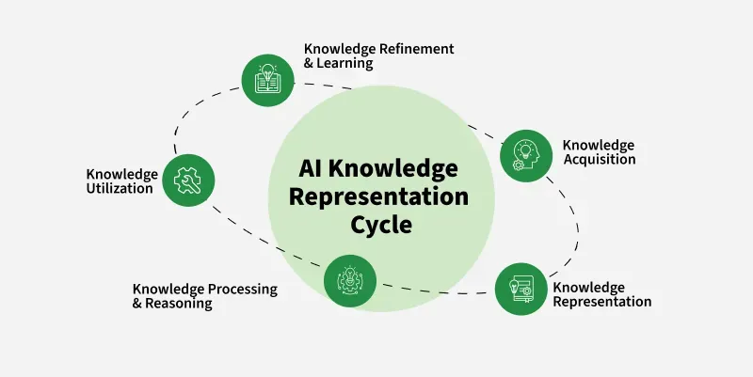

AI Knowledge Cycle

This cycle ensures that AI remains adaptive and improves over time.

**1. Knowledge Acquisition**: AI gathers data from various sources, including structured databases, unstructured text, images, and real-world interactions. Techniques such as machine learning, natural language processing (NLP), and computer vision enable this acquisition.

**2. Knowledge Representation** : Once acquired, knowledge must be structured for efficient storage and retrieval. Represented through methods explained above:

**3. Knowledge Processing & Reasoning**: AI applies logical inference, probabilistic models, and deep learning to process knowledge. This step allows AI to:

* Draw conclusions (deductive and inductive reasoning)
* Solve problems using heuristic search and optimization
* Adapt through reinforcement learning and experience

**4. Knowledge Utilization**: AI applies knowledge to real-world tasks, including decision-making, predictions, and automation. Examples include:

* Virtual assistants understanding user queries
* AI-powered recommendation systems suggesting content
* Self-driving cars making real-time navigation decisions

**5. Knowledge Refinement & Learning**: AI continuously updates its knowledge base through feedback loops. Techniques like reinforcement learning, supervised fine-tuning, and active learning help improve accuracy and adaptability. This ensures AI evolves based on new data and experiences.

*The AI Knowledge Cycle is iterative. AI systems refine knowledge continuously, ensuring adaptability and long-term learning. This cycle forms the backbone of intelligent systems, enabling them to grow smarter over time.*

**Types of Knowledge in AI**

AI systems rely on different types of knowledge to function efficiently. Each type serves a specific role in reasoning, decision-making, and problem-solving. Below are the primary types of knowledge used in AI:

**1. Declarative Knowledge (Descriptive Knowledge)**

Declarative knowledge consists of facts and information about the world that AI systems store and retrieve when needed. It represents "what" is known rather than "how" to do something. **This type of knowledge is often stored in structured formats like databases, ontologies, and knowledge graphs**.

*For example, a fact such as "Paris is the capital of France" is declarative knowledge. AI applications like search engines and virtual assistants use this type of knowledge to answer factual queries and provide relevant information.*

**2. Procedural Knowledge (How-To Knowledge)**

Procedural knowledge**defines the steps or methods required to perform specific tasks**. It represents ***"how" to accomplish something rather than just stating a fact***.

*For instance, knowing how to solve a quadratic equation or how to drive a car falls under procedural knowledge. AI systems, such as expert systems and robotics, utilize procedural knowledge to execute tasks that require sequences of actions. This type of knowledge is often encoded in rule-based systems, decision trees, and machine learning models.*

**3. Meta-Knowledge (Knowledge About Knowledge)**

Refers to knowledge about **how information is structured, used, and validated**. It helps AI determine the reliability, relevance, and applicability of knowledge in different scenarios.

*For example, an AI system deciding whether a piece of medical advice comes from a trusted scientific source or a random blog post is using meta-knowledge. This type of knowledge is crucial in AI models for filtering misinformation, optimizing learning strategies, and improving decision-making.*

**4. Heuristic Knowledge (Experience-Based Knowledge)**

Heuristic knowledge is derived from experience, intuition, and trial-and-error methods. It allows AI systems to make educated guesses or approximate solutions when exact answers are difficult to compute.

*For example, a navigation system suggesting an alternate route based on past traffic patterns is applying heuristic knowledge. AI search algorithms, such as A* search and genetic algorithms, leverage heuristics to optimize problem-solving processes, making decisions more efficient in real-world scenarios.*

**5. Common-Sense Knowledge**

Common-sense knowledge ***represents basic understanding about the world that humans acquire naturally but is challenging for AI to learn***. It includes facts like "**water is wet" or "if you drop something, it will fall**."

*AI systems often struggle with this type of knowledge because it requires* ***contextual understanding beyond explicit programming****.*

Researchers are integrating common-sense reasoning into AI using large-scale knowledge bases such as ConceptNet, which helps machines understand everyday logic and improve their interaction with humans.

**6. Domain-Specific Knowledge**

Domain-specific knowledge focuses on specialized fields such as medicine, finance, law, or engineering. It includes highly detailed and structured information relevant to a particular industry.

For instance, in the medical field, AI-driven diagnostic systems rely on knowledge about symptoms, diseases, and treatments. Similarly, financial AI models use economic indicators, risk assessments, and market trends. Expert systems and AI models tailored for specific industries require domain-specific knowledge to provide accurate insights and predictions.

**Challenges in Knowledge Representation**

While knowledge representation is fundamental to AI, it comes with several challenges:

1. **Complexity**: Representing all possible knowledge about a domain can be highly complex, requiring sophisticated methods to manage and process this information efficiently.
2. **Ambiguity and Vagueness**: Human language and concepts are often ambiguous or vague, making it difficult to create precise representations.
3. **Scalability**: As the amount of knowledge grows, AI systems must scale accordingly, which can be challenging both in terms of storage and processing power.
4. **Knowledge Acquisition**: Gathering and encoding knowledge into a machine-readable format is a significant hurdle, particularly in dynamic or specialized domains.
5. **Reasoning and Inference**: AI systems must not only store knowledge but also use it to infer new information, make decisions, and solve problems. This requires sophisticated reasoning algorithms that can operate efficiently over large knowledge bases.

**Applications of Knowledge Representation in AI**

Knowledge representation is applied across various domains in AI, enabling systems to perform tasks that require human-like understanding and reasoning. Some notable applications include:

1. **Expert Systems**: These systems use knowledge representation to provide advice or make decisions in specific domains, such as medical diagnosis or financial planning.
2. **Natural Language Processing (NLP)**: Knowledge representation is used to understand and generate human language, enabling applications like chatbots, translation systems, and sentiment analysis.
3. **Robotics**: Robots use knowledge representation to navigate, interact with environments, and perform tasks autonomously.
4. **Semantic Web**: The Semantic Web relies on ontologies and other knowledge representation techniques to enable machines to understand and process web content meaningfully.
5. **Cognitive Computing**: Systems like IBM's Watson use knowledge representation to process vast amounts of information, reason about it, and provide insights in fields like healthcare and research.

**Conclusion**

Knowledge representation is a foundational element of AI, enabling machines to understand, reason, and act on the information they process. By leveraging various representation techniques, AI systems can tackle complex tasks that require human-like intelligence. However, challenges such as complexity, ambiguity, and scalability remain critical areas of ongoing research. As AI continues to evolve, advancements in knowledge representation will play a pivotal role in the development of more intelligent and capable systems.